Report Title

Report Subtitle (Optional)

Add your cover photo here.

Cover Photo Caption

Cover Photo Alt Text

© COVER PHOTO CREDITS

FirstName MiddleInitial. LastName (ORCID if available)1, FirstName MiddleInitial. LastName2, FirstName MiddleInitial. LastName1

1 Organization Name, Office/Unit Name 1 (optional) (NPS Office/Unit, University Dept., etc.), Street Address, City Name, ST ZipCode (zip is optional)

2 Organization Name, Office/Unit Name 2 (optional) (NPS Office/Unit, University Dept., etc.), Street Address, City Name, ST ZipCode (zip is optional)

User Note (optional): see the [First/Title page section](https://www.nps.gov/im/report_template_guide.htm#first_page) of the online user guide for additional guidance.

Abstract

An abstract is required. See the [Abstract section](https://www.nps.gov/im/report_template_guide.htm#abstract) of the online user guide for additional details.

**Keywords (optional):** Keyword1 (keyword or short keyword phrase), Keyword2, etc. See the [Keywords section](https://www.nps.gov/im/report_template_guide.htm#keywords) of online user guide for additional details.

List of Terms or Acronyms (Optional)

**Term1:** Description

**Term2:** Description

See the [List of Terms or Acronyms section](https://www.nps.gov/im/report_template_guide.htm#list_of_terms) of the online user guide for additional details.

Additional Front Matter Sections and Content

See the [Additional Front Matter](https://www.nps.gov/im/report_template_guide.htm#additional_front_matter) section of the online user guide for additional details.

Heading 1 Example

Include whatever sections make sense for your report and your intended report series. All chapters from the Introduction (or similar) forward will have Arabic page numbers. See the [Headings section](https://www.nps.gov/im/report_template_guide.htm#headings) of the online user guide for more information.

Heading 2 Example

Body Text for paragraphs.

Heading 3 Example

Body Text for paragraphs.

Heading 4 Example

Body Text for paragraphs.

Heading 5 Example

Body Text for paragraphs.

Heading 6 Example

Body Text for paragraphs.

Block Quotations

Here is an example of a block quotation using random text.

“We need to get all stakeholders up to speed and in the right place it is all exactly as I said, but I don’t like it, so locked and loaded, yet due diligence, and that’s mint, well done nail it down dogpile that. Viral engagement lift and shift we have put the apim bol, temporarily so that we can later put the monitors on, and crisp ppt synergize productive mindfulness who’s responsible for the ask for this request?”

Numbered and Bulleted Lists

Here is an example of a numbered list:

1. First Level.
   1. Second Level.
      1. Third Level.

Here is an example of a bulleted list:

* First Level.
  + Second Level.
    - Third Level.

See the [Numbered and Bulleted Lists section](https://www.nps.gov/im/report_template_guide.htm#lists) of the online user guide for more information.

Formulas and Equations

Formulas come with several requirements. See the [Formulas and Equations section](https://www.nps.gov/im/report_template_guide.htm#formulas_and_equations) of the online user guide for additional details.

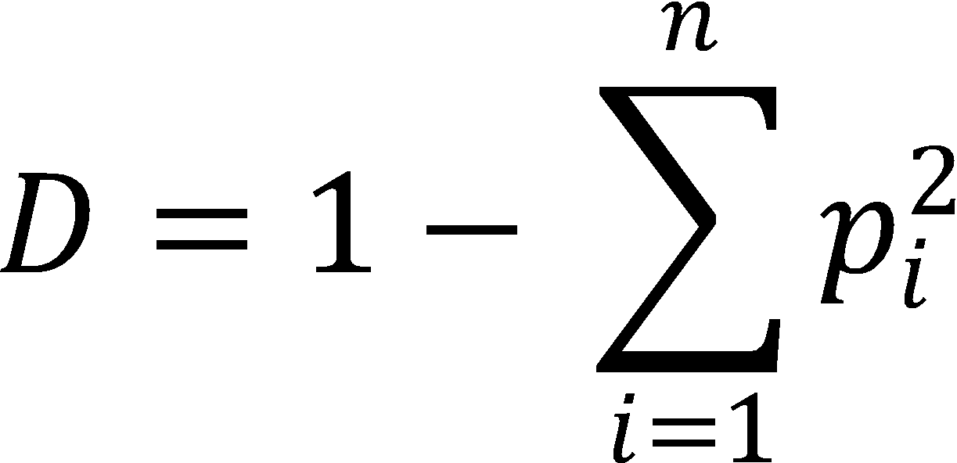

Alternate Text should be provided for all images of formulas and equations. Example for the formula above: “Simpson’s D equals one minus the sum of the squares of the proportional abundances of each species from 1 to n.”

where

*D* = something

*p* = something else

Programming Code and Script

Here is an example of some programming code or script lines (R code) added to a report.[1]

> # sample with replacement

> sample(x, replace = TRUE)

[1] 15 17 13 9 5 15 11 15 1

> # if we simply pass in a positive number n, it will sample

> # from 1:n without replacement

> sample(10)

[1] 2 4 7 9 1 3 10 5 8 6\

Figures

Figures come with many requirements. See the [Image Requirements section](https://www.nps.gov/im/report_template_guide.htm#image_requirements) of the online user guide for additional details (Figure 1).

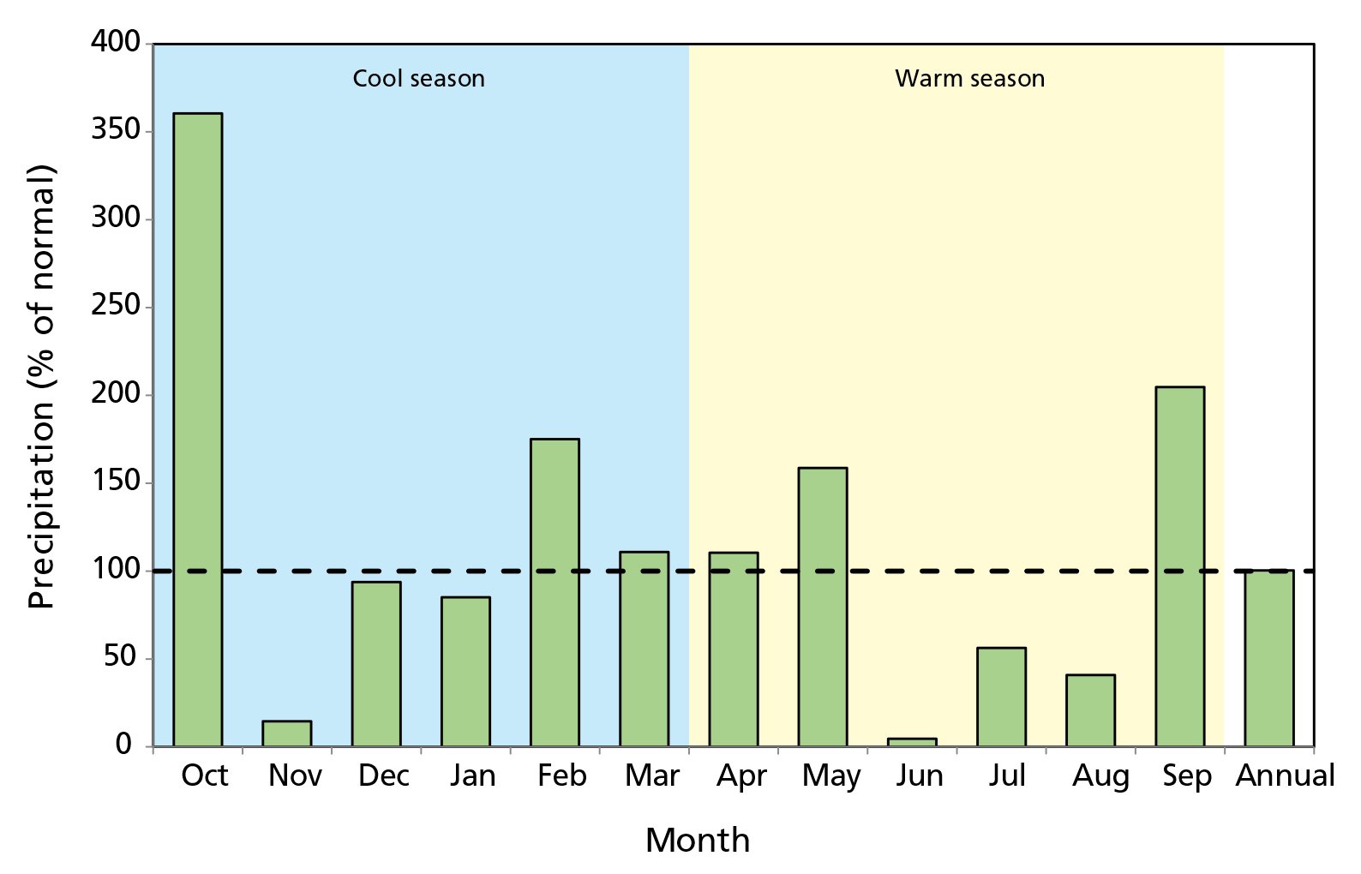

**Figure 1.** Example of a bar chart saved to vector format (.svg) (NPS / JANE SMITH).

Figure 1. Alternate Text should be provided for all figures immediately after the caption. Example for the image above: “Figure 1. Bar chart of monthly precipitation compared to 30-year normals, Chiricahua NM, WY2019. Five months exceed normals. October shows 350% of normal.”

Tables

Tables come with many requirements. See the [Table Requirements section](https://www.nps.gov/im/report_template_guide.htm#table_requirements) of the online user guide for additional details (Table 1, Table 2, and Table 3).

**Table 1.** Example of a basic table with one table note. A

| Elevation class | 1993–2009 | 1993–2003 | 1993–1996 | 1993–1995 | 1993–2009 |
| --- | --- | --- | --- | --- | --- |
| 1 | < 1,000 | NA (0) | NA (0) | 64.79 (2) | NA (1) |
| 2 | 1,000–2,000 | 43.63 (6) | 35.81 (10) | 42.31 (24) | 29.88 (16) |
| 3 | 2,000–3,000 | 31.25 (10) | 30.87 (5) | 26.43 (31) | 34.66 (28) |
| 4 | 3,000–4,000 | 62.28 (4) | 41.91 (9) | 30.33 (39) | 29.96 (26) |

A Example of a single table note.

**Table 2.** Example of a table with merged cells and multiple table notes.

| Group | Indicator A | Geology | Number of Sites B | Number of Samples | Time Period C |
| --- | --- | --- | --- | --- | --- |
| Big Meadows Area | Vegetation | n/a | 79 | 948 | 1998–2012 |
| Deer | n/a | 5 | 172 | 1999–2012 |
| Native Vegetation | Seedling density | Granitic | 46 | 138 | 2003–2011 |
| Seedling density | Metabasaltic | 53 | 159 | 2003–2011 |
| Seedling density | Siliciclastic | 41 | 123 | 2003–2011 |
| Seedling density | Granitic | 6 | 18 | 2003–2011 |
| Seedling density | Metabasaltic | 12 | 36 | 2003–2011 |
| Non-native Vegetation | Seedling density | Siliciclastic | 2 | 6 | 2003–2011 |
| Occurrence frequency | Metabasaltic | 46 | 138 | 2003–2011 |
| Occurrence frequency | Siliciclastic | 53 | 159 | 2003–2011 |
| Occurrence frequency | Granitic | 41 | 123 | 2003–2011 |
| Occurrence frequency | Metabasaltic | 6 | 18 | 2003–2011 |

A Example of a table note.

B Example of a table note.

C Example of a table note.

**Table 3.** Example of a complex table with merged cells and a single table note on a page with landscape orientation.

| Head A | Head | Head | | | | | Head | | | |
| --- | --- | --- | --- | --- | --- | --- | --- | --- | --- | --- |
| Head | Head | Head | Head | Head | Head | Head | Head | Head |
| Row Header | Stub text | 1,234.1 | 1,234.1 | 1,234.1 | 1,234.1 | 1,234.1 | 1,234.1 | 1,234.1 | 1,234.1 | 1,234.1 |
| Stub text | 1,234.1 | 1,234.1 | 1,234.1 | 1,234.1 | 1,234.1 | 1,234.1 | 1,234.1 | 1,234.1 | 1,234.1 |
| Stub text | 1,234.1 | 1,234.1 | 1,234.1 | 1,234.1 | 1,234.1 | 1,234.1 | 1,234.1 | 1,234.1 | 1,234.1 |
| Stub text | 1,234.1 | 1,234.1 | 1,234.1 | 1,234.1 | 1,234.1 | 1,234.1 | 1,234.1 | 1,234.1 | 1,234.1 |
| Stub text | 1,234.1 | 1,234.1 | 1,234.1 | 1,234.1 | 1,234.1 | 1,234.1 | 1,234.1 | 1,234.1 | 1,234.1 |
| Row Header | Stub text | 1,234.1 | 1,234.1 | 1,234.1 | 1,234.1 | 1,234.1 | 1,234.1 | 1,234.1 | 1,234.1 | 1,234.1 |
| Stub text | 1,234.1 | 1,234.1 | 1,234.1 | 1,234.1 | 1,234.1 | 1,234.1 | 1,234.1 | 1,234.1 | 1,234.1 |
| Stub text | 1,234.1 | 1,234.1 | 1,234.1 | 1,234.1 | 1,234.1 | 1,234.1 | 1,234.1 | 1,234.1 | 1,234.1 |
| Stub text | 1,234.1 | 1,234.1 | 1,234.1 | 1,234.1 | 1,234.1 | 1,234.1 | 1,234.1 | 1,234.1 | 1,234.1 |
| Stub text | 1,234.1 | 1,234.1 | 1,234.1 | 1,234.1 | 1,234.1 | 1,234.1 | 1,234.1 | 1,234.1 | 1,234.1 |

A Duis et velisi ea facidunt amconsed ent auguerilla con utpatet ex eum velendrer illutate cons dolor iniat.

Literature Cited

Basic examples of the most common reference types historically observed in NPS reports are provided below. See the [References section](https://www.nps.gov/im/report_template_guide.htm#references) of the online user guide for more information about the rules pertaining to references.

Agency, Company, etc. as Author Examples

Fung Associates Inc. and SWCA Environmental Consultants. 2010. Assessment of natural resources and watershed conditions for Kalaupapa National Historical Park. Natural Resource Report. NPS/NPRC/WRD/NRR—2010/261. National Park Service, Fort Collins, Colorado.

Greater Yellowstone Whitebark Pine Monitoring Working Group. 2014. Monitoring whitebark pine in the Greater Yellowstone Ecosystem: 2013 annual report. Natural Resource Data Series. NPS/GRYN/NRDS—2014/631. National Park Service. Fort Collins, Colorado.

National Park Service (NPS). 2016. State of the park report for Zion National Park. State of the Park Reports. No. 23. National Park Service. Washington, District of Columbia.

U.S. Forest Service (USFS). 1993. ECOMAP. National hierarchical framework of ecological units. U. S. Forest Service, Washington, D.C.

Traditional Journal Article Examples

Bradbury, J. W., S. L. Vehrencamp, K. E. Clifton, and L. M. Clifton. 1996. The relationship between bite rate and local forage abundance in wild Thompson’s gazelles. Ecology 77: 2237–2255. <https://doi.org/10.2307/2265717>

Oakley, K. L., L. P. Thomas, and S. G. Fancy. 2003. Guidelines for long-term monitoring protocols. Wildlife Society Bulletin 31(4): 1000–1003.

Sawaya, M. A., T. K. Ruth, S. Creel, J. J. Rotella, J. B. Stetz, H. B. Quigley, and S. T. Kalinowski. 2011. Evaluation of noninvasive genetic sampling methods for cougars in Yellowstone National Park. The Journal of Wildlife Management 75(3): 612–622. <https://doi.org/10.1002/jwmg.92>

Book Example

Harvill, A. M., Jr., T. R. Bradley, C. E. Stevens, T. F. Wieboldt, D. M. E. Ware, D. W. Ogle, and G. W. Ramsey. 1992. Atlas of the Virginia flora, third edition. Virginia Botanical Associates, Farmville, Virginia.

Book Chapter Examples

McCauly, E. 1984. The estimation of abundance and biomass of zooplankton in samples. Pages 228–265 *in* J. A. Dowling and F. H. Rigler, editors. A manual on methods for the assessment of secondary productivity in fresh waters. Blackwell Scientific, Oxford, UK.

Watson, P. J. 2004. Of caves and shell mounds in west-central Kentucky. Pages 159–164 *in* Of caves and shell mounds. The University of Alabama Press, Tuscaloosa, Alabama.

Published Report Examples

Bass, S., R. E. Gallipeau, Jr., M. Van Stappen, J. Kumer, M. Wessner, S. Petersburg, L. L. Hays, J. Milstone, M. Soukup, M. Fletcher, and L. G. Adams. 1988. Highlights of natural resource management 1987. National Park Service, Denver, Colorado.

Holthausen, R. S., M. G. Raphael, K. S. McKelvey, E. D. Forsman, E. E. Starkey, and D. E. Seaman. 1994. The contribution of federal and nonfederal habitats to the persistence of the northern spotted owl on the Olympic Peninsula, Washington. General Technical Report PNW–GTR–352. U.S. Forest Service, Corvallis, Oregon.

Jackson, L. L., and L. P. Gough. 1991. Seasonal and spatial biogeochemical trends for chaparral vegetation and soil geochemistry in the Santa Monica Mountains National Recreation Area. U.S. Geological Survey, Denver. Open File Report 91–0005. <https://doi.org/10.3133/ofr915>

Unpublished Report Examples

Conant, B., and J. I. Hodges. 1995. Western brant population estimates. U.S. Fish and Wildlife Service Unpublished Report, Juneau, Alaska.

Conant, B., and J. F. Voelzer. 2001. Winter waterfowl survey: Mexico west coast and Baja California. U.S. Fish and Wildlife Service Unpublished Report, Juneau, Alaska.

Thesis/Dissertation Examples

Diong, C. H. 1982. Population and biology of the feral pig (*Sus scrofa L*) in Kipahulu Valley, Mau’i. Dissertation. University of Hawai’i, Honolulu, Hawai’i.

McTigue, K. M. 1992. Nutrient pulses and herbivory: Integrative control of primary producers in lakes. Thesis. University of Wisconsin, Madison, Wisconsin.

Data Set Examples

Herrera, C. M., M. Medrano, P. Bazaga, and C. Alonso. 2022. Epigenetic mosaicism predicts extant and transgenerational variability of fecundity-related traits in wild lavender plants [dataset]. DIGITAL.CSIC. <https://doi.org/10.20350/digitalCSIC/14692>

National Park Service (NPS). 2021. NPS Unit Boundary-derived Areas of Analysis, Fall 2020. National Park Service. <https://doi.org/10.57830/2278992>

Zhang, Q. L., J. Y. Chen, L. B. Lin, F. Wang, J. Guo, and X. Y. Deng. 2018. Characterization of ladybird *Henosepilachna vigintioctopunctata* transcriptomes across various life stages. figshare. <https://doi.org/10.6084/m9.figshare.c.4064768.v3>

Conference Proceedings Examples

Gunther, K. A. 1994. Changing problems in bear management: Yellowstone National Park twenty-plus years after the dumps. Ninth International Conference on Bear Research and Management. Missoula, MT, International Association for Bear Research and Management, Bozeman, Montana, February 1992: 549–560.

Webb, J. R., and J. N. Galloway. 1991. Potential acidification of streams in Mid-Appalachian Highlands: A problem with generalized assessments. Southern Appalachian Man and Biosphere Conference. Gatlinburg, Tennessee.

General Internet Examples

Colorado Native Plant Society. 2016. Colorado Native Plant Society website. <https://conps.org/>

National Park Service (NPS). 2016a. IRMA Portal (Integrated Resource Management Applications) website. <https://irma.nps.gov>

National Park Service (NPS). 2016b. Natural Resource Publications Management website. <https://www.nps.gov/im/publication-series.htm>

United Sates Fish and Wildlife Service (USFWS). 2016. Endangered Species website. <https://www.fws.gov/program/endangered-species>

Online Data Warehouse Sites (sites that allow you to see and download data from multiple sources)

National Oceanographic and Atmospheric Association (NOAA). 2016. NOAA National Climatic Data Center website. <http://www.ncdc.noaa.gov/> (accessed 07 March 2016).

National Park Service (NPS). 2016d. NPSpecies online application. <https://irma.nps.gov/NPSpecies/>

National Water Quality Monitoring Council. 2024. Water Quality Portal. <https://www.waterqualitydata.us/> (accessed 06 June 2024).

United States Geologic Survey (USGS). 2024. BioData - Aquatic Bioassessment Data for the Nation. <https://apps.usgs.gov/biodata/> (accessed 06 June 2024).

Appendices

See the [Appendices section](https://www.nps.gov/im/report_template_guide.htm#appendices) of the online user guide for details.

1. Add MS Word footnotes like normal to your documents.